Program No.: 08

**Aim:**

Create a Tuple and apply Tuple operations in python.

**Topics covered:**

Implementing Tuples in Python.

**Course Outcome**

CO2: Implement basic data structures in python

Cognitive Level: K3.

**Case Studies:**

***Case Study 01:***

***Problem Statement:***

Python program to Sort a List of Tuples in Increasing Order by the Last Element in Each Tuple.

***Problem Solution:***

1. Take a list of tuples from the user.

2. Define a function which returns the last element of each

tuple in the list of tuples.

3. Define another function with the previous function as

the key and sort the list.

4. Print the sorted list.

5. Exit.

***Program/Source Code:***

#Python program to Sort a List of Tuples in Increasing Order by the Last Element in Each Tuple.

"""

Case Study : 01

File Name : cse1.py

Topic : Tuples

"""

size=int(input("Enter the size of list : "))

l = [None] * size

for i in range(size):

p=int(input("Enter the first element of tuple : "))

q=int(input("Enter the second element of tuple : "))

a=(p,q)

l[i]=a

temp=0

for i in range(size):

a=l[i]

for j in range(size):

b=l[j]

if(a[len(a)-1]<b[len(b)-1]):

temp=l[i]

l[i]=l[j]

l[j]=temp

print(l)

***Program Explanation:***

1. Take a list of tuples from the user.

2. Define a function which returns the last element of each

tuple in the list of tuples.

3. Define another function with the previous function as

the key and sort the list.

4. Print the sorted list.

5. Exit.

***Runtime Test Cases:***

1. Enter list of tuples :[(1,2),(3,4),(2,1)]

[(2, 1), (1, 2), (3, 4)]

1. Enter list of tuples :[(2,1),(3,4)]

[(2, 1), (3, 4)]

**Output:**

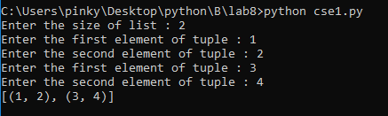

***Case Study 02:***

***Problem Statement:***

Python Program to Remove All Tuples in a List of Tuples with the USN Outside the Given Range.

***Problem Solution:***

1. Take in the lower and upper roll number from the user.

2. Then append the prefixes of the USN’s to the roll

numbers.

3. Using list comprehension, find out which USN’s lie in the

given range.

4. Print the list containing the tuples.

5. Exit.

***Program/Source Code:***

# Python Program to Remove All Tuples in a List of Tuples with the USN Outside the Given Range.

"""

Case Study : 02

File Name : cse2.py

Topic : Tuples

"""

#creating the empty list

lst=[]

n=int(input("Enter the no of tuples you want to insert in a list : "))

for i in range(n):

print("Enter the tuple values : ")

t=tuple((x.strip()) for x in input().split(','))

lst.append(t)

lower=int(input("Enter the lower roll number : "))

upper=int(input("Enter the upper roll number : "))

res=[]

for i in lst:

num=int(i[1][8:])

if num>=lower and num<=upper:

res.append(i)

print("The students between the given roll numbers are")

print(res)

***Program Explanation:***

1. Take in the lower and upper roll number from the user.

2. Then append the prefixes of the USN’s to the roll

numbers.

3. Using list comprehension, find out which USN’s lie in the

given range.

4. Print the list containing the tuples.

5. Exit.

***Runtime Test Cases:***

1.Enter the no of tuples you want to insert in a list : 3

Enter the tuple values :

jv,178w1a0544

Enter the tuple values :

sasank,178w1a0537

Enter the tuple values :

chiruhas,178w1a0505

Enter the lower roll number : 20

Enter the upper roll number : 50

The students between the given roll numbers are

[('jv', '178w1a0544'), ('sasank', '178w1a0537')]

2.Enter the no of tuples you want to insert in a list : 2

Enter the tuple values :

jv,178w1a0509

Enter the tuple values :

harsha,178w1a0544

Enter the lower roll number : 30

Enter the upper roll number : 50

The students between the given roll numbers are

[('harsha', '178w1a0544')]

**Output:**

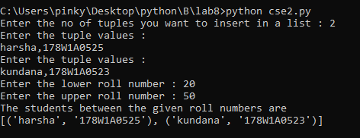

**Result:**

Implementation of Creating a List and applying list operations in python done successfully.